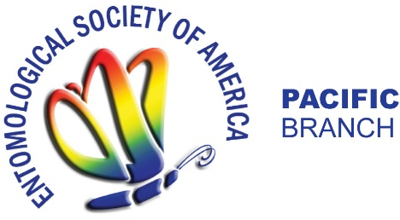

PBESA Student Travel Award Application Form

Below is the information that will need to be provided on the online application. All applications must be completed online at https://entsocawards.smapply.org/prog/pacific_branch_student_travel_awards
by January 10, 2022 12 PM (EST)

Applicant Information
- Name:
- Contact information (mailing address, phone number, email address)
- Address and full name of the institution of graduate/undergraduate studies
- Degree program
Undergraduate;
Master’s degree;
Doctoral degree
- Beginning date of the student’s current degree program
- Anticipated date of graduation
- Current GPA
- Title of presentation planned for Pacific Branch ESA meeting
- Type of presentation:
Oral Presentation
Poster Presentation
- Presentation session:
Student Competition
Invited Speaker in Symposium
General Session
- Indicate if you are/will be receiving additional financial support. Please indicate the amount and or items covered by these sources.
Your Department/University. Amt. $__________
An Advisor/Major Professor. Amt. $__________
Other funding sources (Please list). Amt. $_________
- Abstract of presentation (250 words or less).
- A brief description (1 paragraph) of the student’s current research activities
- A brief description (1 paragraph) of the student’s participation on ESA committees or meeting activities
- Include BRIEF letter of support from supporting faculty member (300 words or less)

